

CSCE 4560/5560 Spring 2026

LAB # 1: Lab 1 Creating a Full-Stack Web Development Environment on Kali Linux 2025.4

Submitted By: Prakriti Dhungel
CSCE 5560 – Secure Electronic Commerce

Objective: In this lab you will configure a full-stack web development environment using Kali Linux 2025.4, you will go through the basic setup of a web server environment configuring Apache, MySQL (MariaDB), PHP, and WordPress.

Preparation:
- Virtual Machine: Download the Kali Linux 2025.4OVA file from the following link: KALI25.4.ova

Please refer to the Canvas page Files -> “Lab Support Files", for additional information to import the OVA file into VirtualBox.
- Credentials: Use the following login credentials:

Username: sec-lab Password: untccdc
- Hostname: Ensure that your hostname is set to your EUID.
- Screenshots: If multiple screenshots are required(feel free to put several screenshots), attach them as needed. Ensure that your username and hostname are visible in the screenshots.
- Clarification: For screenshots involving terminal commands, ensure both your hostname and username are clearly visible.
- Captions: Provide a brief caption for each screenshot, explaining what you have accomplished and what is being shown.
- Explanations: Include a short explanation of your outcomes and understanding for each part of the hands-on training.
Table 1: Important Notes for Submission

This table highlights the essential points you need to consider before submitting your work. Make sure to meet all the requirements to avoid any issues with your submission and to prevent losing points
s
Attention(s):

- Login to with your regular credentials.

The credentials are as follows:
Username: sec-lab Password: untccdc
- First, set the hostname: open the terminal window and type the below command, where “EUID” must be replaced with your actual EUID. (You will be prompted by the root password; remember that it is the same as that of the normal user.)
sudo hostnamectl set-hostname EUID
- Close the terminal, open it again and confirm that in the command prompt, the hostname is now the same as your EUID.
- Next, update the /etc/hosts file: type the following command:
sudo nano /etc/hosts
- Then, replace the old hostname with your EUID.
- Save the file and exit.

PART 1 BASIC SERVER SETUP

If the user

All Linux commands definition can be found at:

(Youwill be quized on the commands used in this lab; for example,the purpose of the “apt-get install” command.)

Use the Kali Linux 2025.4for this lab (username: sec-lab / password: untccdc)

Below is the Link for the Pre-built Kali VMLatest Version












system is running on

Learn how to check the Operating system version your

uname -r

Change the root password type

    - passwd
    - Enter your new password
(If you feel that you may forget the password when you access the computer next time. Please change the password back to “untccdc”. Turn off the system and confirm that the password “untccdc” is working.)
Add newuser and password
<<You are adding a new user because using the root account is very dangerous.>>

Add your new user to be a superuser privileges:

In Kali Linux (and most Debian-based systems), administrative privileges are managed through the sudo group. This means that any member of this group can execute administrative commands using sudo. So when we run the following command:





We are adding that user to the group that has sudo privileges.

Switching Between Users When You Are Not Root:

- If you are currently the user Foo and want to switch to bob:


- If you are currently the user Foo and want to switch to root:


or


Switching Between Users When You Are Root:

- To switch from root to bob:


Switching Back to the User sec-lab:

- If you want to return to the sec-lab user:




or simply type:


if you originally switched users using su.

Update and Upgrade Your System

(Iƒ you are not root, you will need to add sudo beƒore the commands below.)

- To update and upgrade your system, run:



Updating the System After Changing the Username or Hostname

After changing your username or hostname, you can update your system using the following commands:

Note 1: Ensure that the network is set to NAT mode.

- Update package lists:




- Upgrade installed packages:




(No need to execute, just understand its purpose):






This command perƒorms a more comprehensive upgrade, handling dependencies and package removals iƒ necessary.

5pts

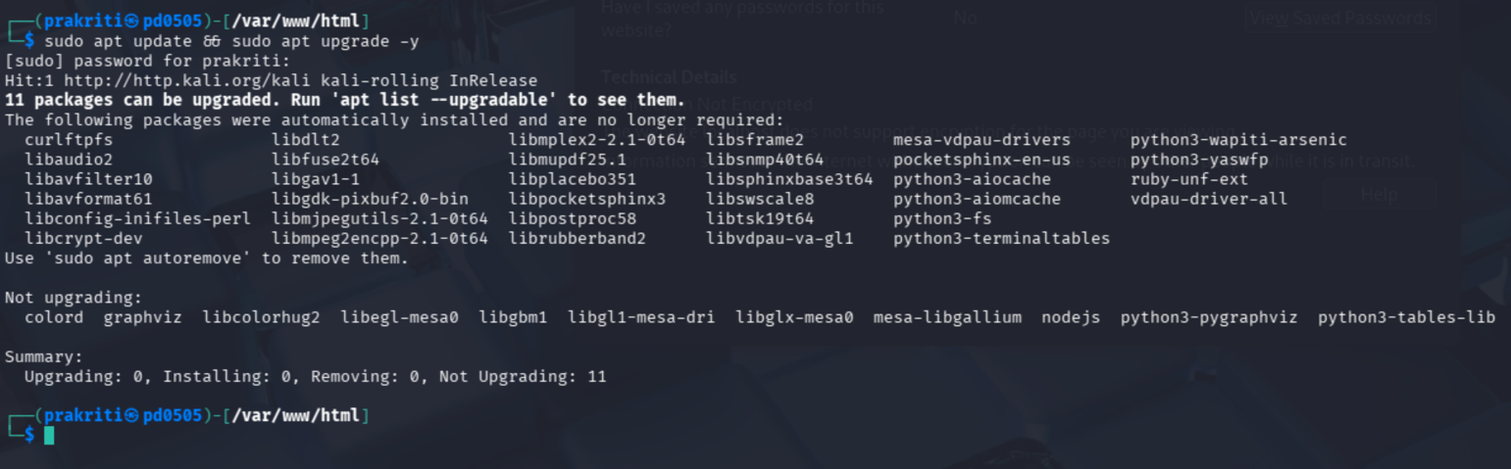
Figure 1Switching from the default Kali user to the newly created user prakriti using su command.

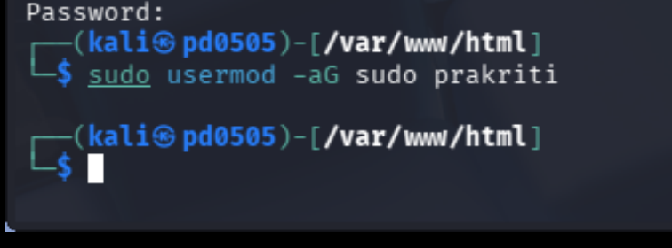
Figure 2Assigning administrative privileges to user prakriti by adding the account to the sudo group

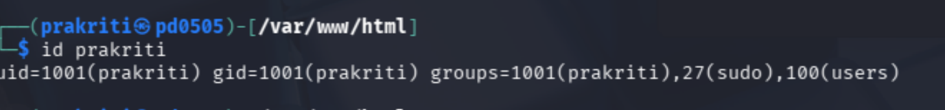
Figure 3Verifying the user identity and group memberships

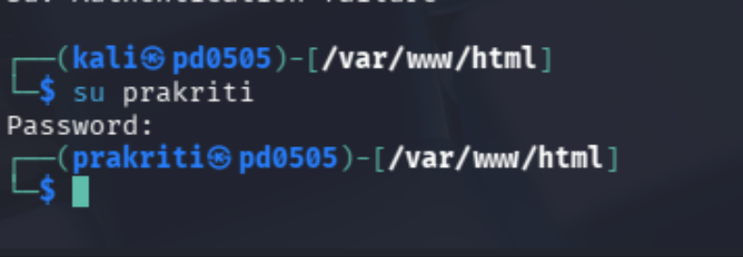
Figure 41Switching from the default Kali user to the newly created user

A new Linux user was created and assigned administrative privileges in this step named prakriti. The user name for the new user account was created by the su prakriti command and was used to change to the default Kali user account. Sudo was then used to execute system update commands, which ensured that the user is authorized to do administrative operations. The id prakriti command was employed to confirm who is being used and what group memberships the user has and it was identified that the account was part of the sudo group. Lastly, the sudo usermod -aG sudo prakriti command was issued to provide the administrative privileges specifically to the user by allowing the user to be added to the sudo group, which would give the user the ability to run privileged commands within the system.

PART 2 INSTALLING APACHE

Install Apache

Open the terminal and type:



- Start and enable Apache:
- Verify Apache Status:

- Find Your IP Address

Then, check your VM IP address use the following command:


(Note down the IP address, e.g., 10.0.2.15.)

Test in your browser:
http://YOUR_IP_ADDRESS

Open a Web Browser to Test the Apache Server

On the host machine, enter the VM's IP address in the browser to check if the Apache server is running:


(Replace <ip_address> with your VM’s actual IP, e.g., http://10.0.2.15.)

Verify Apache is Running

If you see the Apache welcome page, your web server is successfully running.

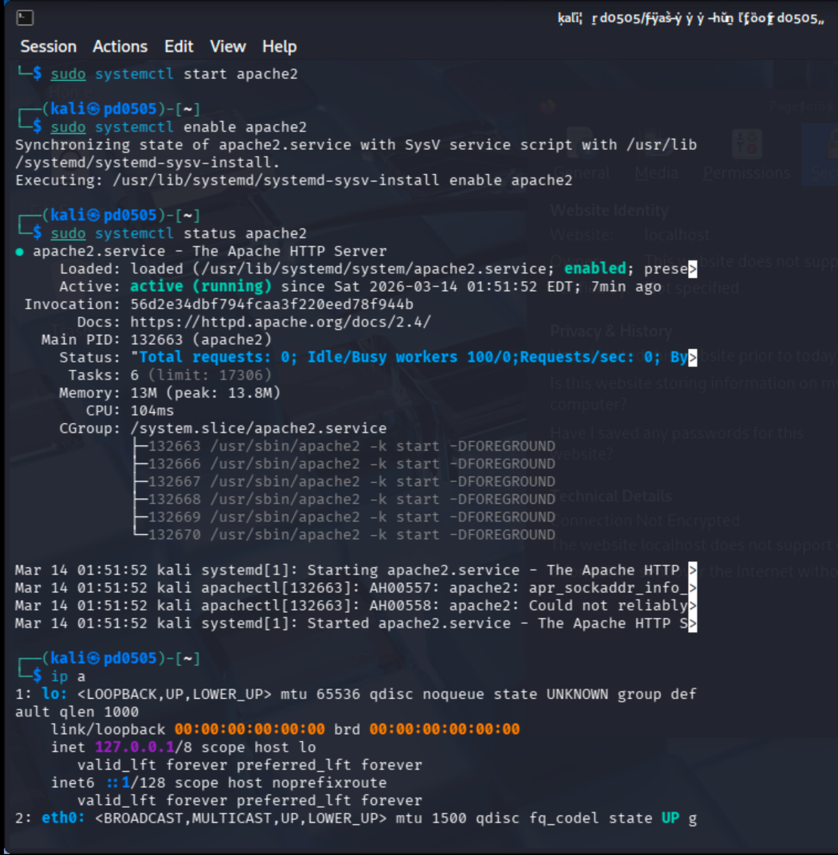
Figure 5 Starting, enabling, and verifying the status of the Apache HTTP server

Look at the Table 1: Important Notes for Submission once again.

Question-1. Attach the screenshot with the corresponding caption and related information about the Apache welcome page?
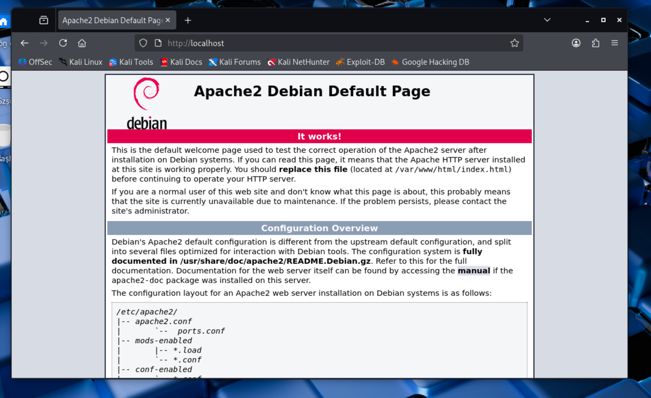
Figure 2Apache2 Debian default web page displayed, confirming that the Apache HTTP server has been successfully installed

The screenshot indicates the Apache2 Debian default page opened via the web browser with the help of the URL localhost. The following page testifies that the Apache web server has been installed successfully and that the server is working well. The default page is also created automatically when the Apache is installed on systems based on Debian and is used as a test page to ensure that the HTTP server is functioning as intended. It further states that the web root directory /var/www/html is properly set up and is the one that can host a web content like HTML, PHP, or a web application like WordPress.
10 pts

To ensure your VM has an internet connection for downloading the necessary files, follow these steps:

- Power off your VM.
- Change the network adapter setting to NAT.
- Power on the VM again.

This will restore the internet connection for future tasks.

PART 3 INSTALL AN SECURE MARIADB (MYSQL-Compatible)

- Introduction to MySQL

MySQL is a powerful database management system used for organizing and retrieving data. Kali Linux uses MariaDB as the default MySQL implementation, which is fully compatible with MySQL.

Install MySQL

To install MySQL, open the terminal and type the following command:







Start and Enable service:

- Run MySQL Secure Installation

Next, run the following command::







  - You will be prompted for your current password for root, so when prompted:
Enter current password for root (enter for none):
OK, successfully used password, moving on...

Press “"Enter” (leave blank)
- Switch to unix socket authentication?

  - Type Yes or Y

- Change the root password?

a. Type N (not required for this lab)

- Answer Y to all remaining security questions.

- Remove Anonymous Users

By default, MySQL allows anonymous users to log in. This is only intended for testing. You should remove this ability by selecting Y when prompted:

Remove anonymous users? [Y/n] y
Success!

Disallow Remote Root Login

To improve security, ensure that the root user can only connect from localhost. Select Y when prompted:
Disallow root login remotely? [Y/n] y Success!

Remove the Test Database

aMySQL comes with a default test database that anyone can access, which is also intended for testing. You should remove this database by selecting Y:
Remove test database and access to it? [Y/n] y
- Dropping test database... Success!
- Removing privileges on test database...
Success!

Reload the Privilege Tables

To ensure that all changes take effect immediately, reload the privilege tables by selecting Y:
Reload privilege tables now? [Y/n] y
Success!

Log in to the database as root:

Sudo mysql

Finish the Setup

You have successfully completed the MySQL installation and initial configuration.

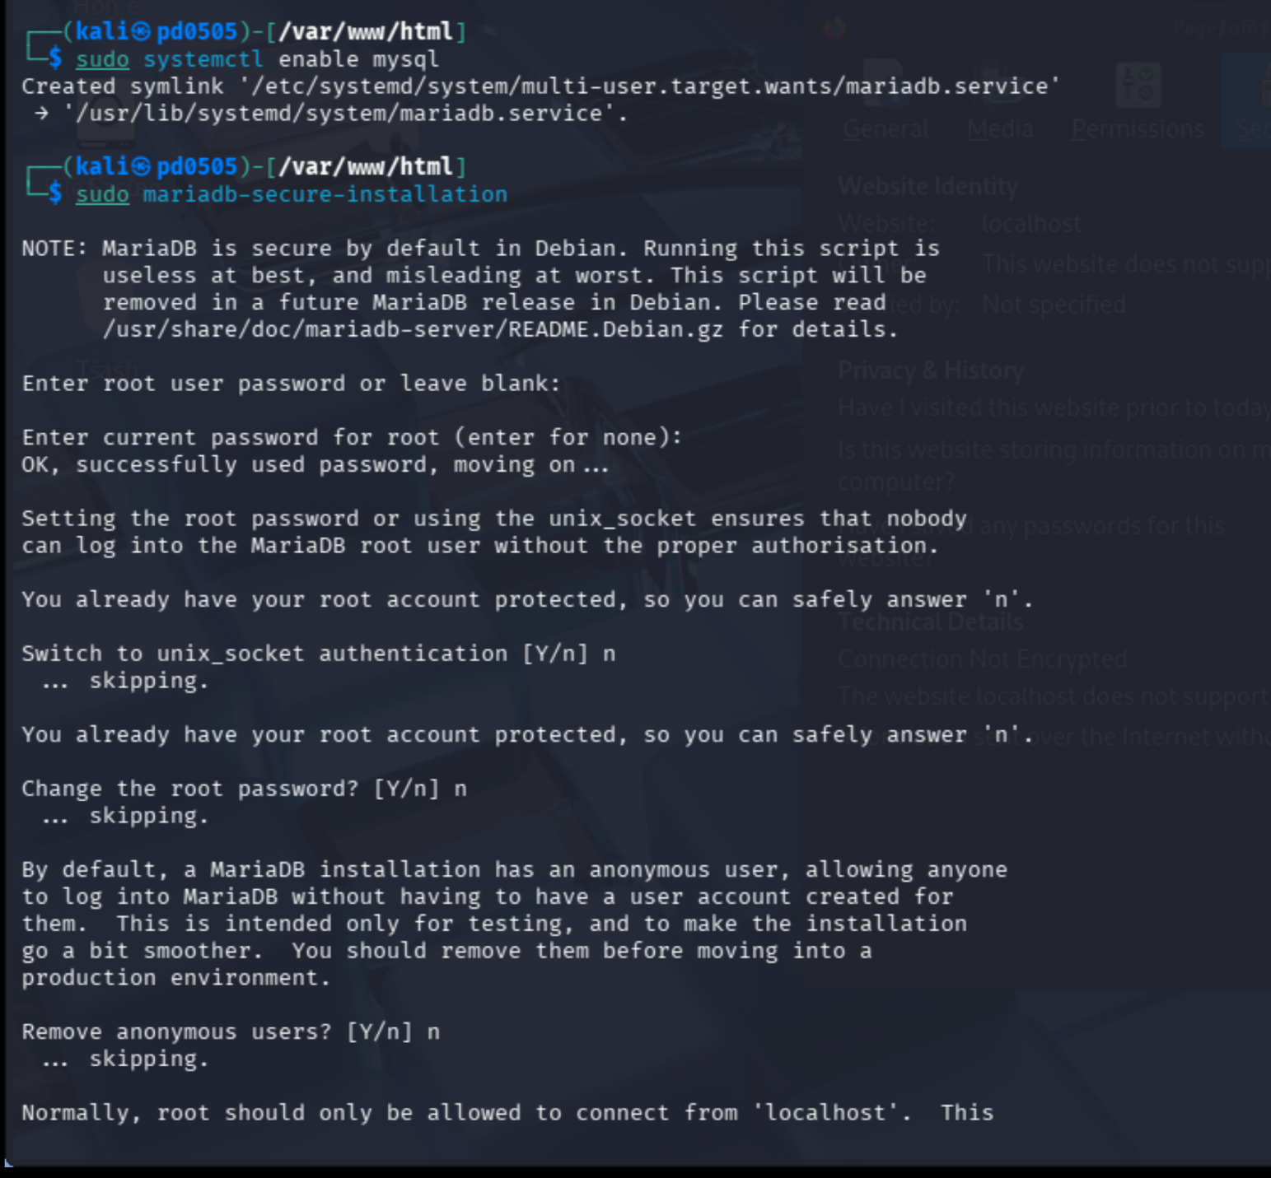
Figure 3Enabling Unix socket authentication and removing anonymous users during the MariaDB secure installation

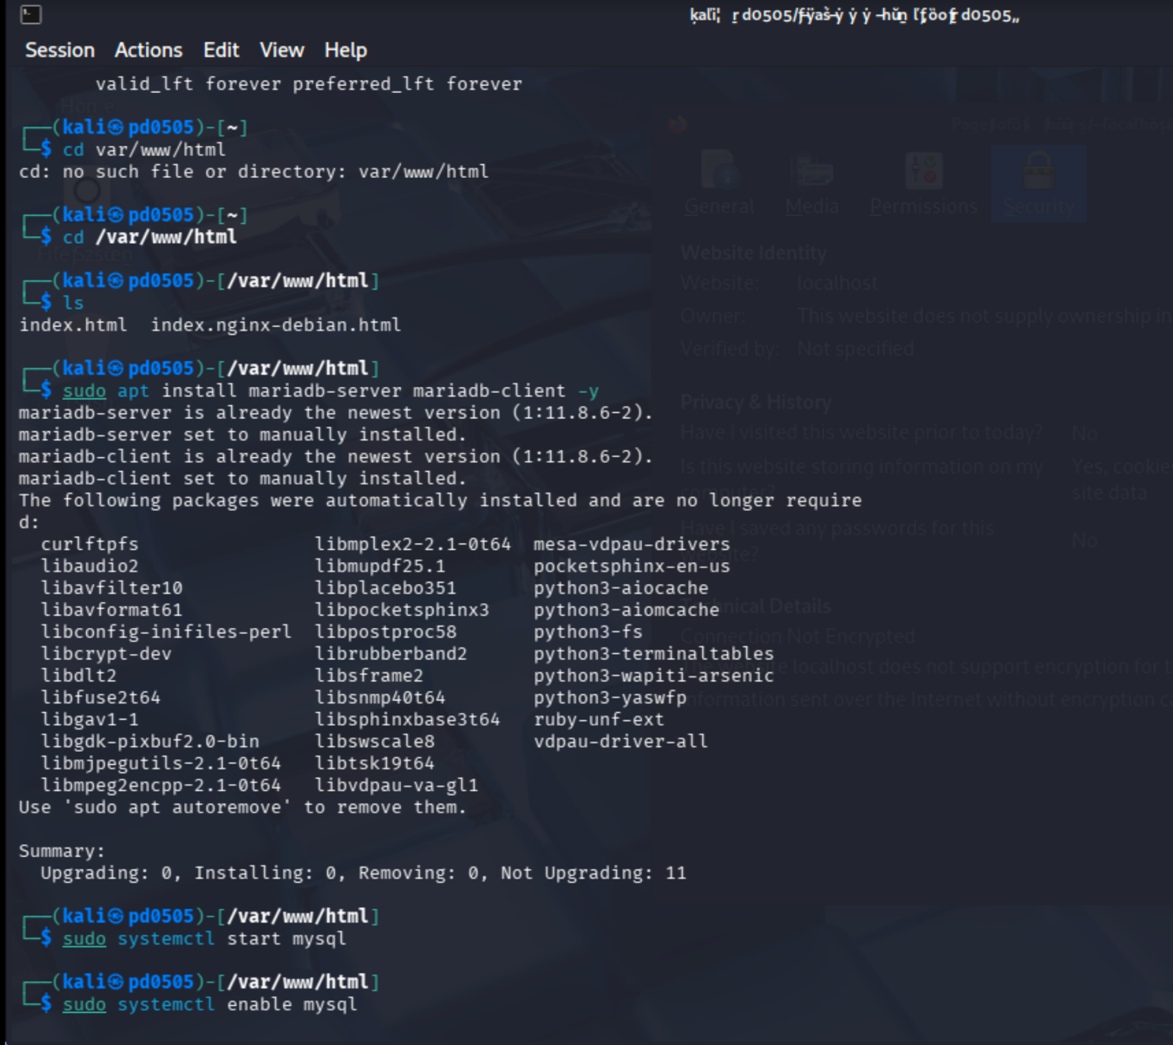
Figure 4Installing the MariaDB server and client packages and enabling the MySQL/MariaDB service using systemctl.

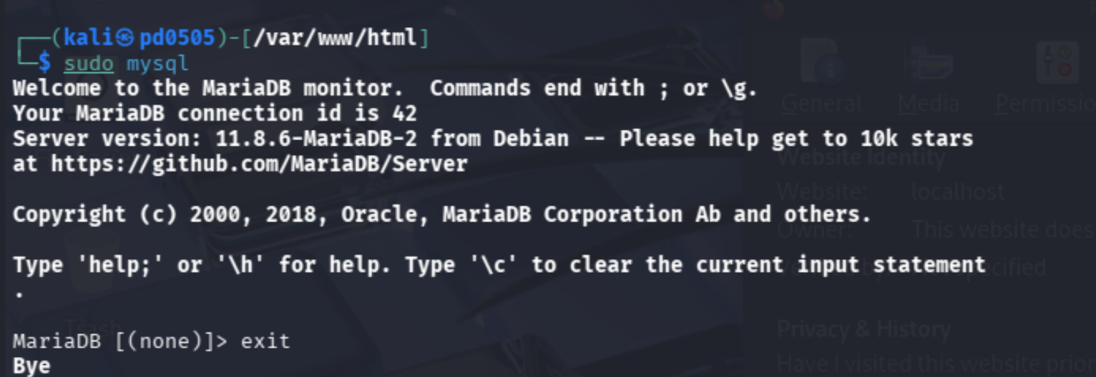
Figure 5Accessing the MariaDB database server through the command line using sudo mysql,

The server and client packages of MariaDB were installed and the database service was enabled. The mariadb-secure-installation was then called to enhance the security of the database through the following options: activation of Unix socket authentication, elimination of anonymous users and imposing stricter access policies. Lastly, MariaDB command line interface was also entered by typing sudo mysql to confirm that the database server was installed and functioning successfully.

PART 4 INSTALL PHP

PHP is an open-source web scripting language widely used to build dynamic web pages.

To Install PHP and Apache module

Open the terminal and type the following command:









After answering "y" to the prompt, PHP will be installed.

Install common extensions:

It may be useful to add PHP to the directory index to serve the relevant PHP index files. To do this execute the following command:

















Restart Apache and verify Apache is active:

- VerifyPHP in the Directory Index

It may be useful to verify PHP in the directory index files. To do this, go to the dir.conf file:



In the file, index.php should be there intothe DirectoryIndex line (if it’s not already there).
The section should look like this:

<IfModule mod_dir.c>
DirectoryIndex index.php index.html index.cgi index.pl index.php index.xhtml index.htm
</IfModule>

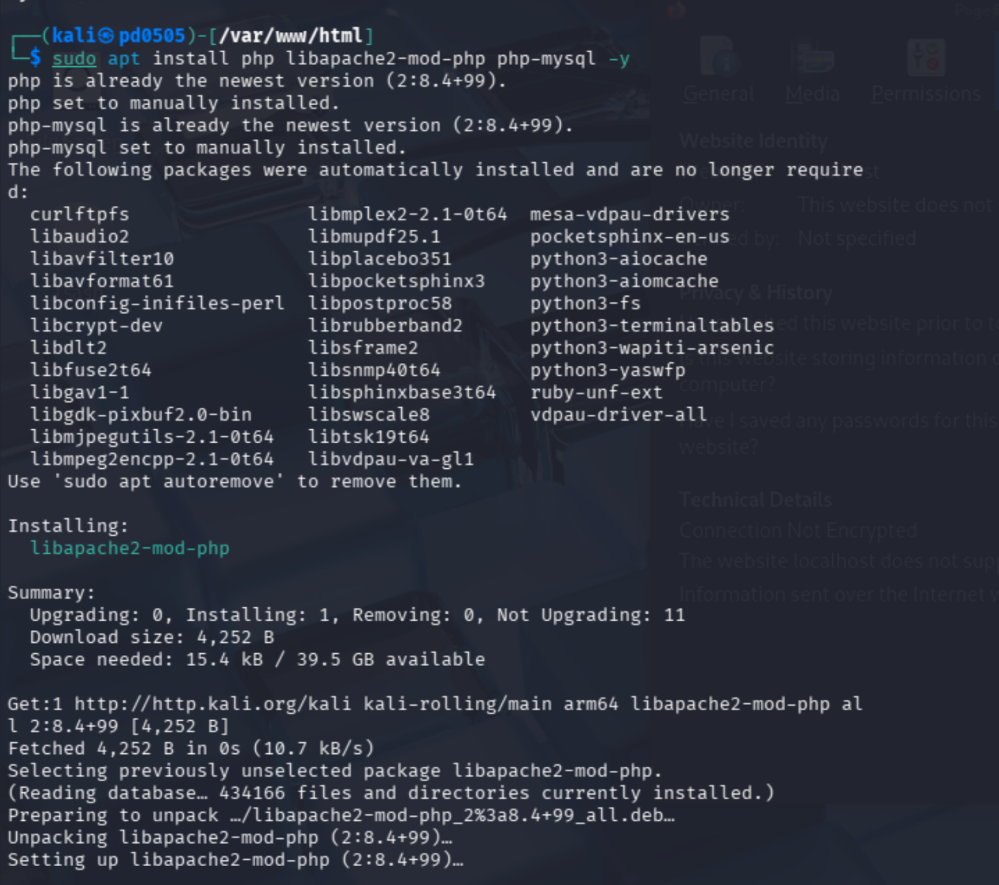
Figure 6 installing Apache PHP module (libapache2-mod-php) and MySQL PHP extension (php-mysql) to enable communication between PHP applications and the MariaDB database server.

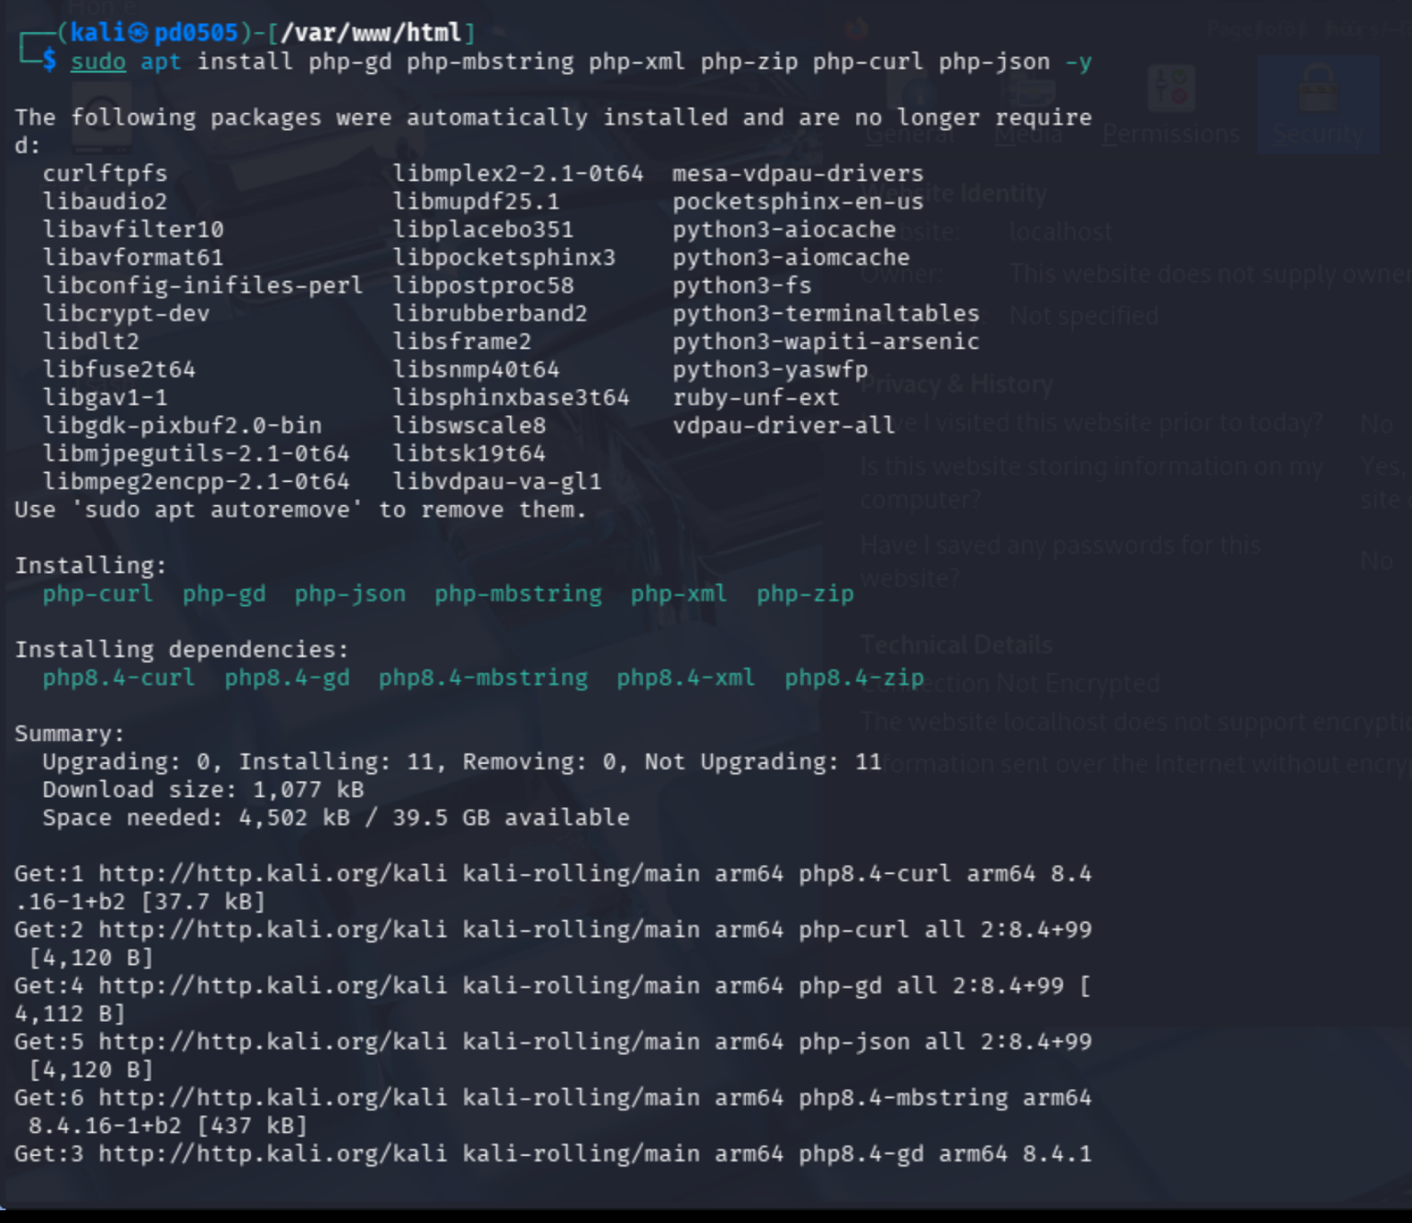
Figure 7Installing required PHP using the apt package manager to support web applications such as WordPress.

PART 5 RESULTS TO SEE PHP ON YOUR SERVER

Create a New PHP File

To set up the PHP info page, first create a new file by running the following command:

Add PHP Info Code

In the new file, add the following line of code:


"Note: In the directory /var/www/hmtl, add the ƒollowing line:"

Save and Exit

Once the code is added, save and exit the file. In nano, you can do this by pressing Ctrl + X, then press Y to confirm, and hit Enter to save.

Restart Apache

To apply the changes and ensure the PHP info page works, restart Apache by running the following command:
10 pts

Verify in your browser:

http://YOUR_IP_ADDRESS/info.php

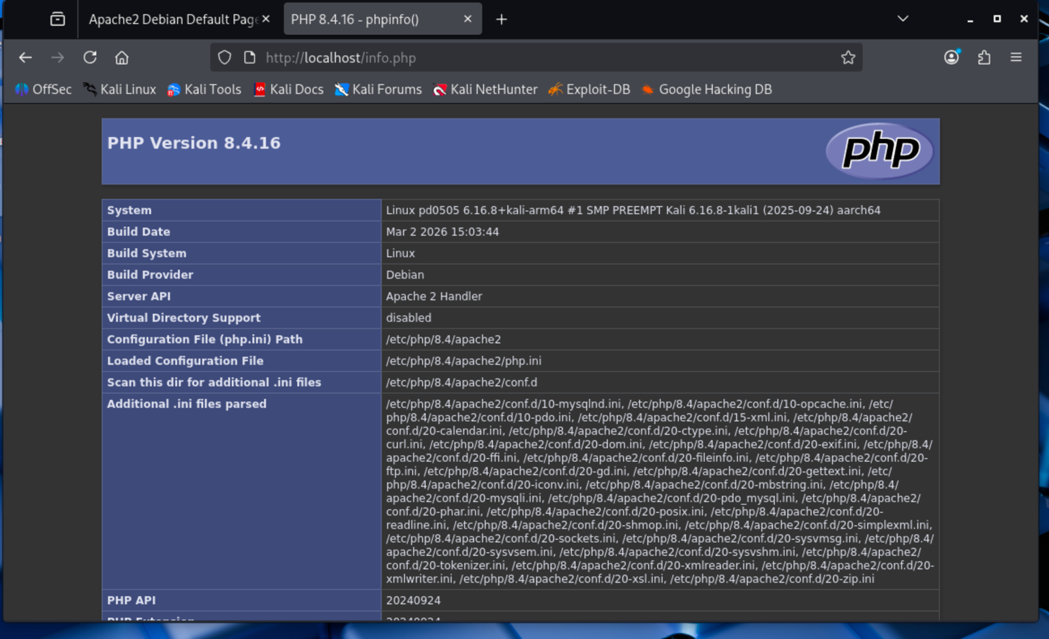
Figure 8PHP information page (phpinfo()) displayed in the browser confirming that PHP 8.4.16 is successfully installed and integrated with the Apache web server.
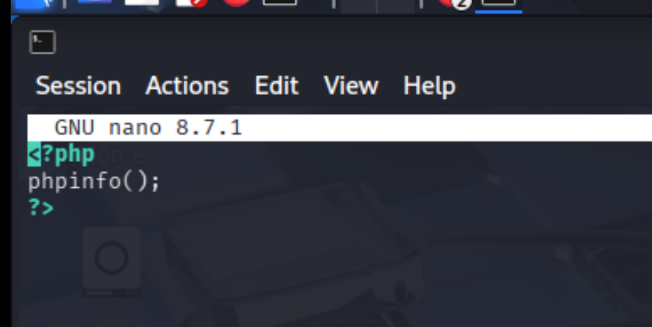
Figure 9Creating a PHP test file using the Nano text editor containing the phpinfo() function to verify PHP configuration

In this step of the installation, the PHP and its required extensions were installed to create dynamic web application functionality. Various modules of php were installed such as php-gd, php-mbstring, php-xml, php-zip, php-curl, and php-json as these are some of the most common modules required to enable several features in the web like image processing, data handling, and API communication. Apache PHP module ( libapache2-mod-php ) and MySQL extension ( php-mysql ) were also installed so that PHP could be run in the Apache web server and communicate with MariaDB database. The PHP test file which included the phpinfo function was then developed and opened in the browser in order to confirm that PHP was properly set up and installed with the web server.

PART 6 INSTALL AND SECURE PHPMYADMIN

Install phpMyAdmin

To install phpMyAdmin, open the terminal and run the following command:

sudo apt install phpmyadmin

Configure phpMyAdmin

During the installation, phpMyAdmin will guide you through basic configuration. Follow these steps when prompted:

  - Select Apache2 for the web server (use the spacebar to select)

  - Choose YES when asked whether to configure the database for phpMyAdmin using
dbconfig-common.

  - Leave the database administrator's password blank:

    - Press Enter (leave blank)

  - When prompted to create a password for phpmyadmin:

    - Enter a new password (example: phpadmin123).
    - Confirm the password.

This password is used internally by phpMyAdmin for configuration storage. It is not the database root password, and it will not be used for login.

After the installation, restart Apache:
sudo systemctl restart apache2

Create a Database Admin user (Required for Login)

Because MariaDB uses unix_socket authentication for root, you must create a database for phpMyAdmin login.

  - Run the following command:
sudo mysql

  - Then execute the following instructions:
CREATE USER 'username'@'localhost' IDENTIFIED BY 'newpassword'; GRANT ALL PRIVILEGES ON *.* TO 'username'@'localhost' WITH GRANT OPTION;
FLUSH PRIVILEGES;
EXIT;

Add phpMyAdmin to Apache Configuration

After the installation is complete, add phpMyAdmin to the Apache configuration:

Modify the Configuration File

In the file, add the following line to include the phpMyAdmin configuration:

Restart Apache

To apply the changes, restart Apache:


Access phpMyAdmin

You can now access phpMyAdmin by opening a browser and going to:
http://your-ip-address/phpmyadmin
(e.g., http://10.0.2.15/phpmyadmin)

To find your IP address, run:
ifconfig

Permissions Issue (Optional)

If you encounter the error "Your Firefox profile cannot be loaded. It may be missing or inaccessible", run the following command to fix the permissions for the created user:
sudo chown -R $USER:$USER ~/.cache/

Question-2. Attach the screen shot of the browser after the above step.
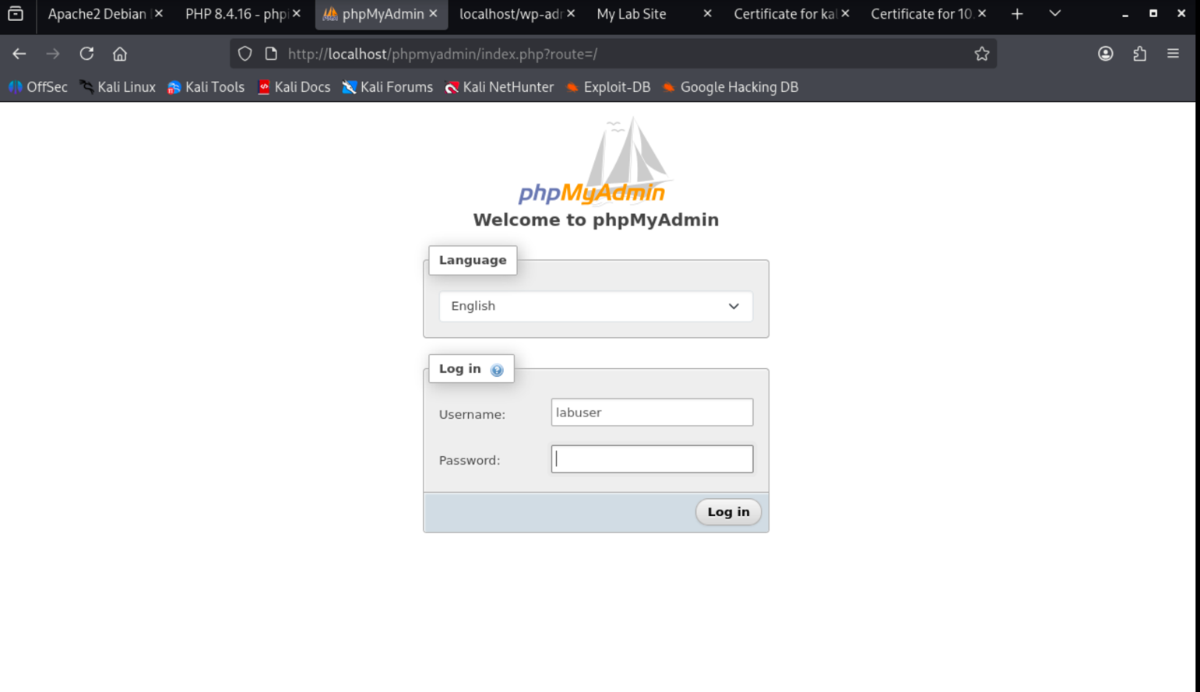
Fig.3. PhPMyAdmin welcome page.

Look at the Table 1: Important Notes for Submission, once again. 10 pts

SECURITY

Unfortunately, older versions of phpMyAdmin have had serious security vulnerabilities, including the possibility for remote users to exploit root access on the underlying virtual private server. Most of these attacks can be prevented by securing the directory with Apache's native user/password restrictions, which will block remote users from attempting to exploit vulnerabilities in older versions of phpMyAdmin.

Set up the .htaccess File

Open the phpMyAdmin Apache configuration file:

- In the <Directory /usr/share/phpmyadmin> section, add the line AllowOverride All under DirectoryIndex, so the section looks like this:
<Directory /usr/share/phpmyadmin> Options FollowSymLinks DirectoryIndex index.php AllowOverride All
</Directory>

Configure the .htaccess File

Note: The dot indicates that it's a hidden ƒile in Unix-based systems.

With AllowOverride All in place, we can set up authentication for accessing the phpMyAdmin login page.

  - Create the .htaccess file in the phpMyAdmin directory:

sudo nano /usr/share/phpmyadmin/.htaccess

  - Add the following text to the file:
AuthType Basic
AuthName "Restricted Files"
AuthUserFile /etc/apache2/.phpmyadmin.htpasswd Require valid-user

Explanation oƒ Each Line:

- AuthType: Defines the authentication method. Here, it is set to Basic, which is standard for HTTP authentication.
- AuthName: The message displayed on the password prompt. You can customize it.
- AuthUserFile: Specifies the path to the password file (we will create it in the next step).
- Require valid-user: Only users defined in the password file can access phpMyAdmin.

Create the .htpasswd File

Now, let’s create the password file to store the valid user credentials.

  - Run the following command to create the .htpasswd file and set up a user:
sudo htpasswd -c /etc/apache2/.phpmyadmin.htpasswd username

  - You’ll be prompted to provide and confirm the password. Once completed, the password will be encrypted and saved in the file.

Restart Apache

To apply the changes, restart Apache:

sudo systemctl restart apache2

Test the Setup

Try accessing phpMyAdmin by entering youripaddress/phpmyadmin in your web browser.

- The default phpMyAdmin username will be phpmyadmin.
- The password will be the one you set during the .htpasswd setup.

Question-3. Attach the screen shot of the prompted window.

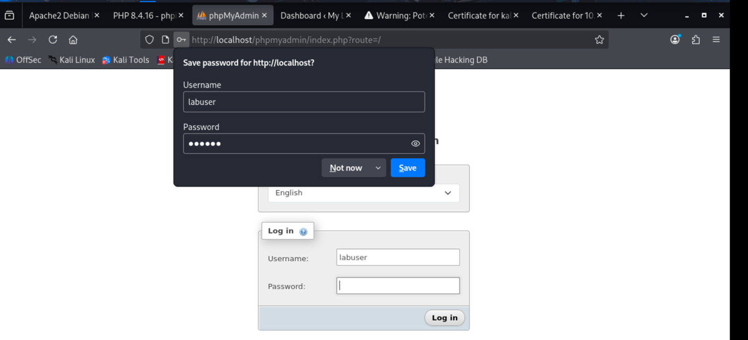
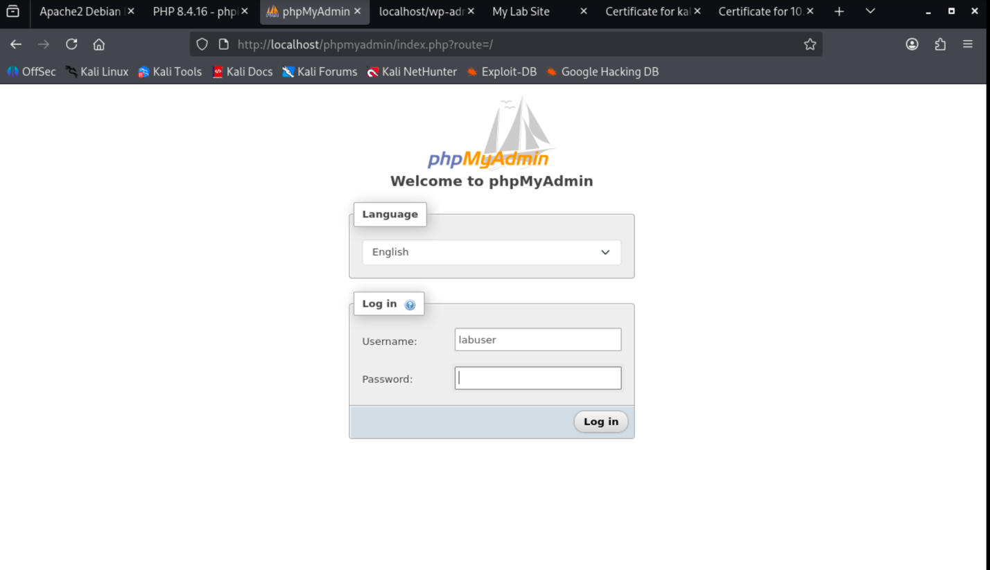
Figure 10 phpmyadmin login popup windows
15 pts

Question-4. Attach the screen shot of the after logon to the prompted window.

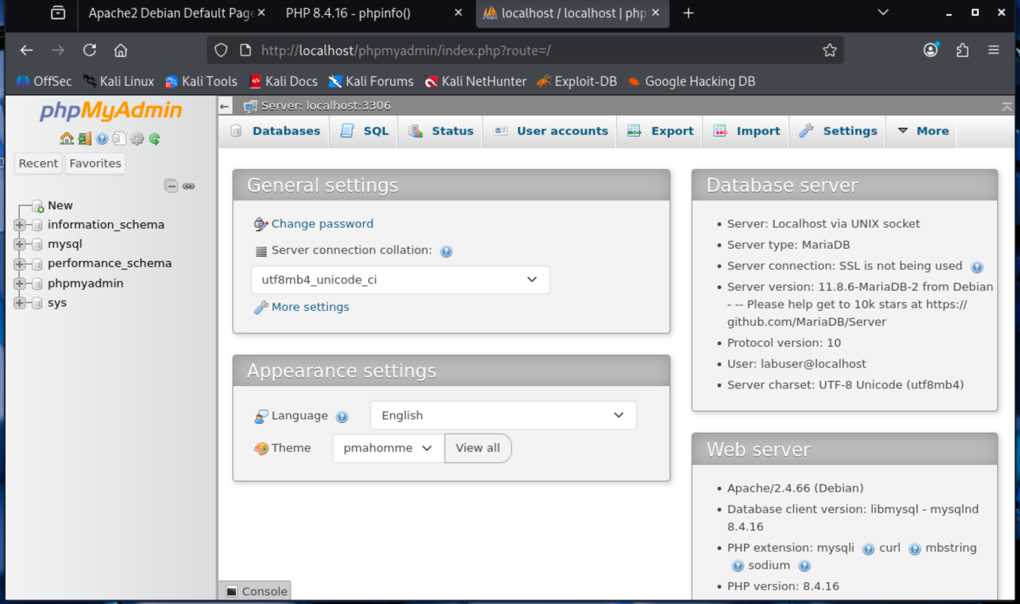
Figure 11phpMyAdmin dashboard accessed, showing successful connection to the MariaDB database server
15 pts

Note: This may be a challenging step because you need to locate the PHP webpage. If any part of the lab instructions is missed, you may not be able to find the PHP webpage, and it will not be accepted.

PART 7 INSTALL WORDPRESS

Download WordPress:



- To unzip the file:




Aƒter unzipping, the WordPress ƒiles will be in a directory called wordpress in the home directory.

Create the WordPress database and user:


Login using your MySQL root password, then ƒollow the commands below.

- Create the database and user (replace wordpress and wordpressuser with your own names if desired):

  - To create the database:

  - To create a new user:


  - Grant privileges to the new user:

- Flush privileges:


- Exit MySQL:


- Setup WordPress configuration:

  - Copy the sample WordPress configuration file:








  - Edit the configuration file:



    - Find the section with the following lines, and replace them with your database details:



- Save and exit the configuration file.

COPY THE FILES TO THE WEBSITE ROOT DIRECTORY:

Transfer WordPress files to the website root:



- Set the correct permissions for the directory:

- First, switch to the web directory:


- Give ownership of the directory to the Apache user (replace username with your actual Linux username):







Access the WordPress installation page:

- Open a browser and navigate to:



- Follow the on-screen instructions to complete the WordPress setup.

To access the WordPress installation page, append /wp-admin/install.php to your site's domain or IP address (e.g., http://example.com/wp-admin/install.php or http://your_ip_address/wp-admin/install.php). Then, fill out the setup form that appears.

Question-5. Attach the screen shot of the browser after accessing the site.

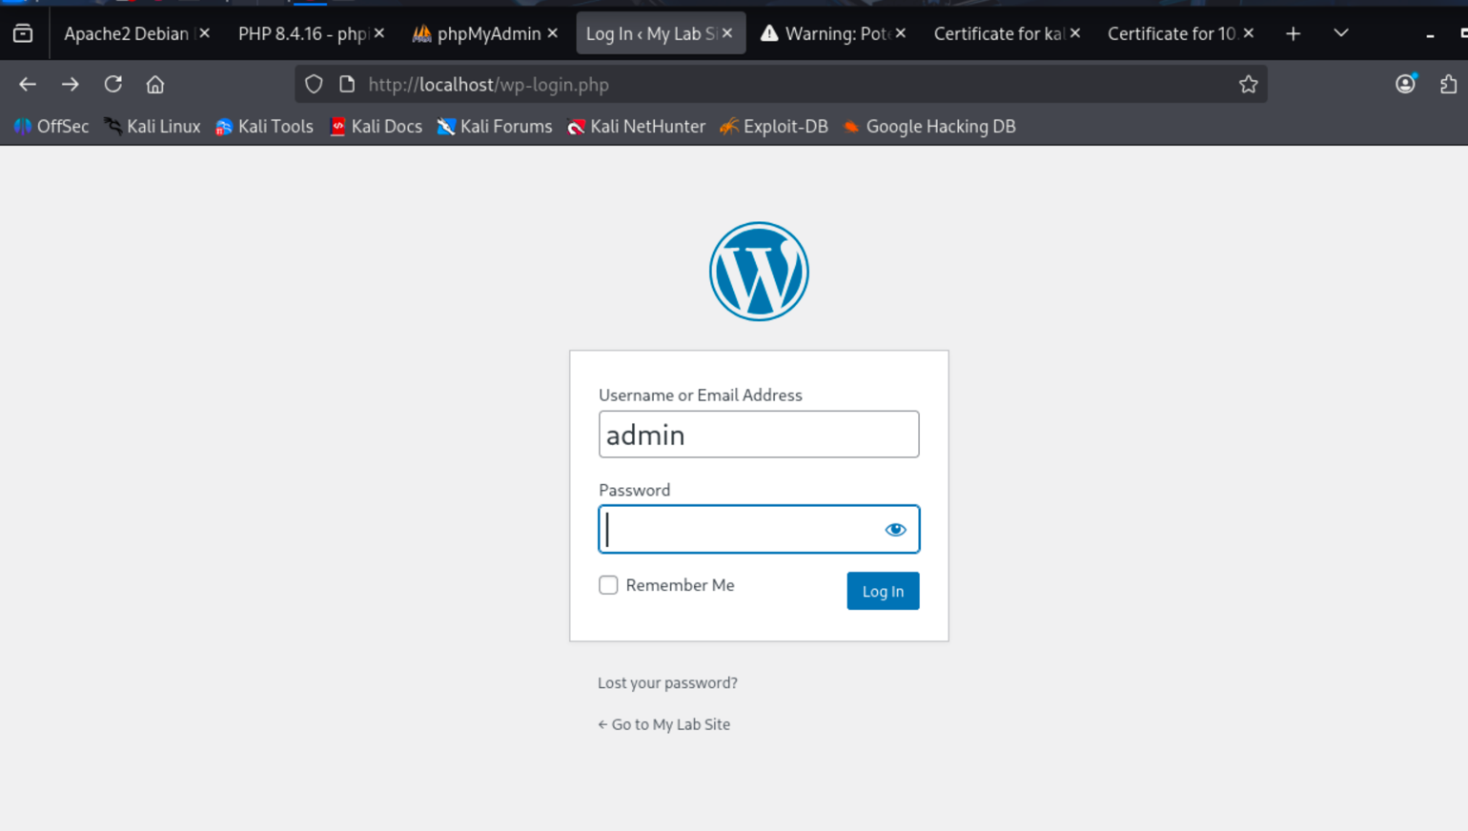
Figure 12wordpress login popup window

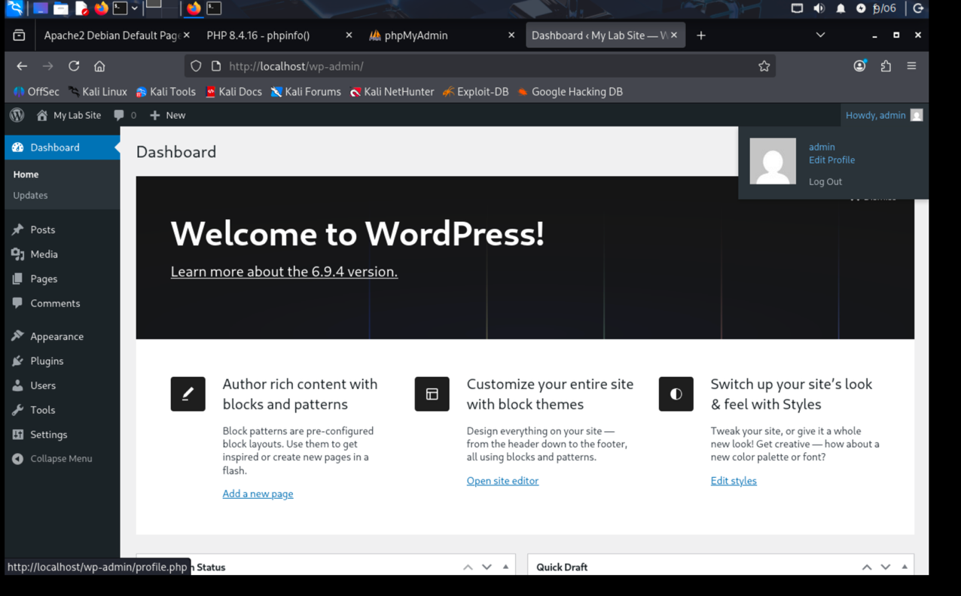
Figure 13WordPress administrative dashboard accesse, confirming that the WordPress content management system was successfully installed

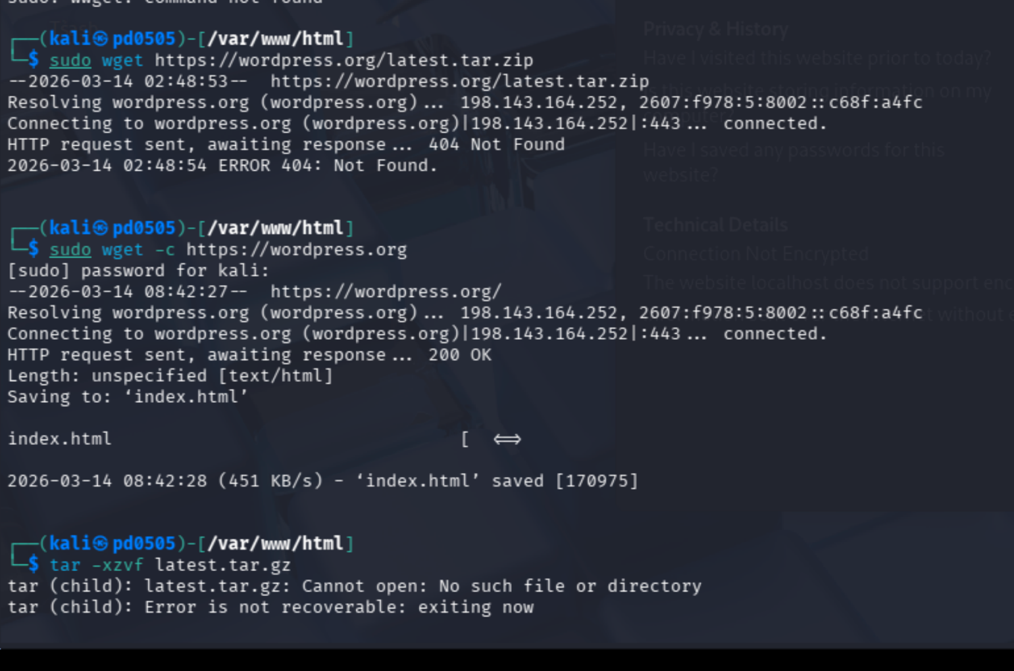
Figure 14installing wordpress

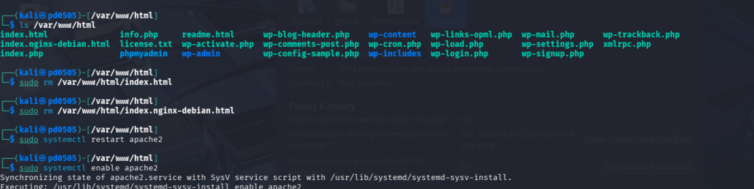
Figure 15Listing files in the /var/www/html directory and removing the default Apache index files to allow WordPress to function as the primary website content.

This is the last part of the lab whereby WordPress was installed and configured in the Apache web server. The Apache default index files had been taken away in the /var/www/html directory in order to enable the wordpress application files to be present as the primary web page content. A new MariaDB database called wordpress was created and a separate database user created with which the WordPress would be allowed to access the database safely. Once the configuration processes were complete, the WordPress administrative dashboard was opened using the browser and this ensured that the content management system was appropriately installed and running on the local server environment.

10 pts

PART 8 CREATING A SSL CERTIFICATE

An SSL certificate is used to encrypt a site's data, ensuring a secure connection. It also allows the server to present its identity to site visitors. SSL certificates can be issued by Certificate Authorities, which validate the server’s identity, while a self-signed certificate lacks third-party validation.

Activate the SSL Module

Run the following command to enable SSL in Apache:


Restart Apache Services

To apply changes, restart Apache:


Create a Directory for the Server Key and Certificate

Create a directory to store the SSL certificate and key:

Create a Self-Signed SSL Certificate

Use this command to create a self-signed SSL certificate and server key. You can modify the validity (365 days) if desired:














This command will generate both the self-signed certificate and the server key, storing them in the newly created directory.

Fill in Certificate Information

The terminal will prompt you to fill in fields for your certificate. The most important field is "Common Name." Enter your domain name or IP address here. The Distinguished Name (DN) information will be requested as follows:






Configure the Virtual Hosts to Use the Certificate

Next, configure the virtual host to display the new SSL certificate. Open the configuration file:





Edit the Configuration

In the section that begins with <VirtualHost _default_:443>, make the following changes:

  - Add your server name (IP address) under the ServerAdmin line:

(For example, ServerName 192.168.56.101 or 10.0.2.15 for NAT connections.)

  - Ensure the following lines are configured correctly:


Enable the Virtual Host

Activate the virtual host for SSL:




Restart Apache

Reload Apache to apply the changes:


Access the Secure Site

In your browser, navigate to https://youraddress. You should be able to see the new certificate. To verify, click on "View Certificate."

Note: you need to get the certificate

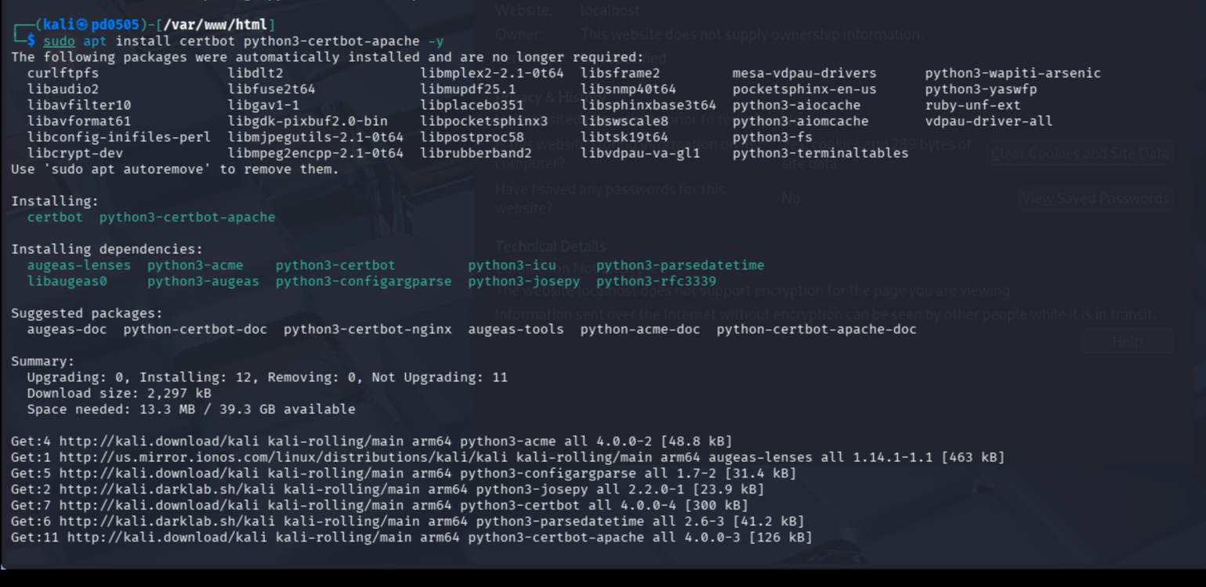
Figure 16Installing SSL certificate management tools (certbot and python3-certbot-apache) required for configuring HTTPS support on the Apache web server.

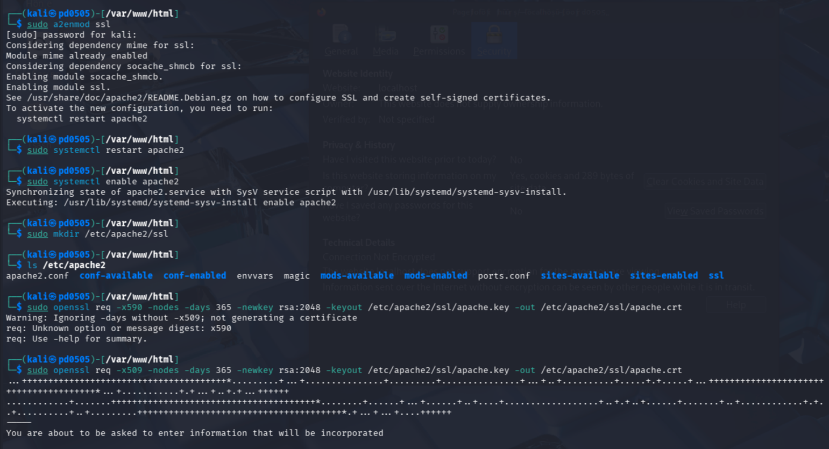
Figure 17 Enabling the Apache SSL module, creating the SSL directory, and generating a self-signed SSL certificate using OpenSSL

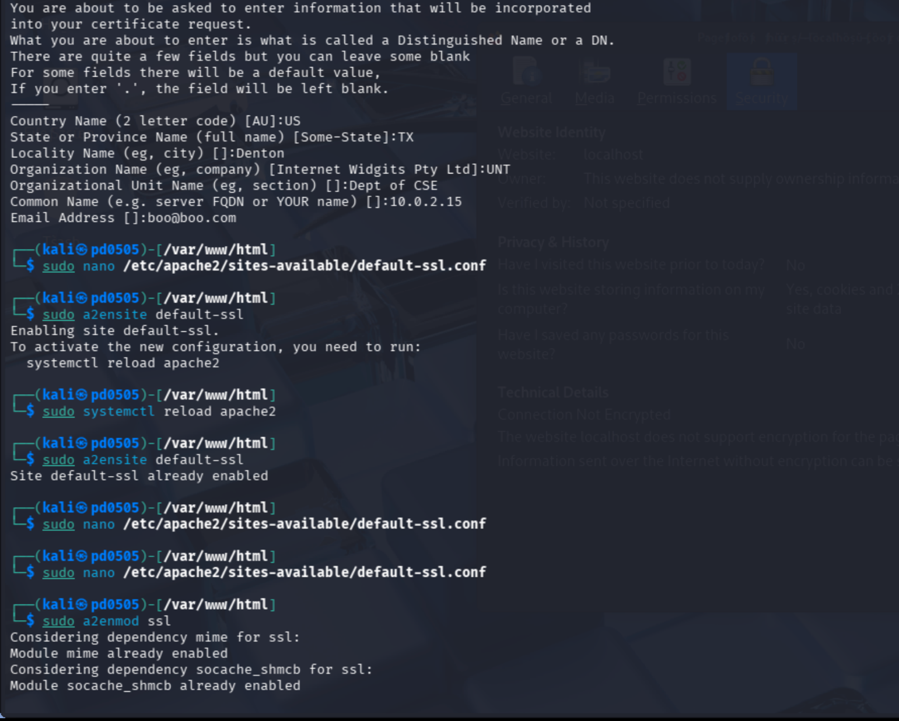
Figure 17Generating and configuring SSL certificates and enabling HTTPS on Apache by editing the default-ssl.conf file and activating the SSL site using a2ensite default-ssl and a2enmod ssl.

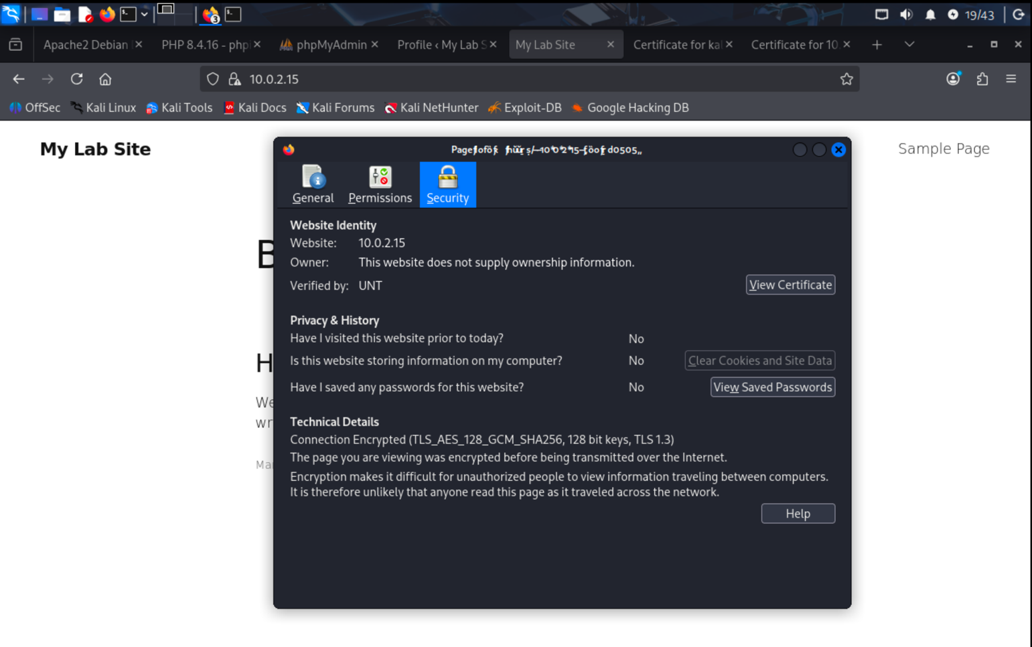
Figure 18WordPress website accessed securely over HTTPS (https://10.0.2.15) with the browser showing an encrypted TLS connection.

Fig 7. we have achieved: to verify SSL certificate with the above information. 25 pts

Question-6. Attach the screen shot of the browser. Click on advanced and view certificate before taking screenshot like above.
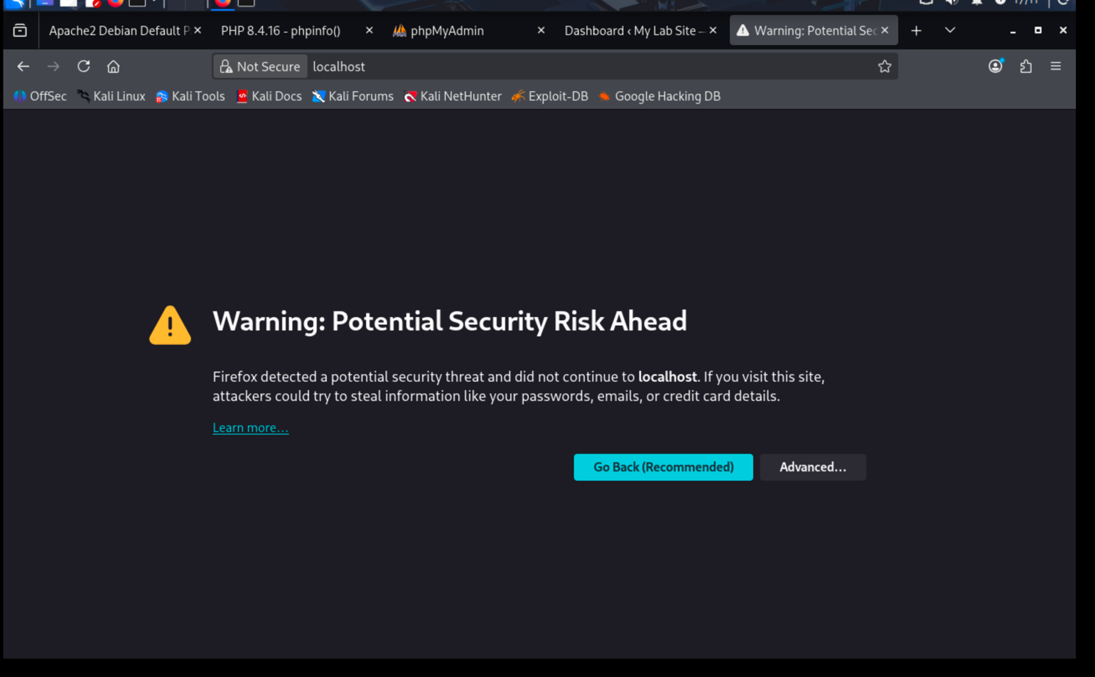
Figure 19 Browser security warning displayed when accessing the local server over HTTPS using a self-signed certificate

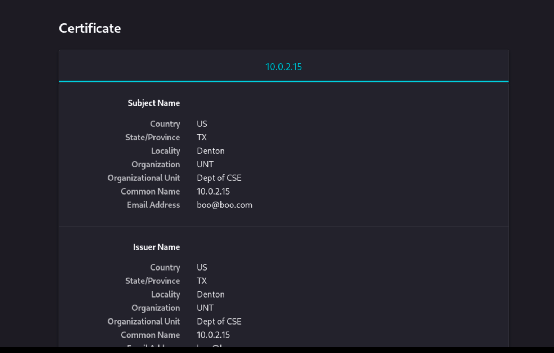
Figure 20Viewing the details of the self-signed SSL certificate showing the subject and issuer information,

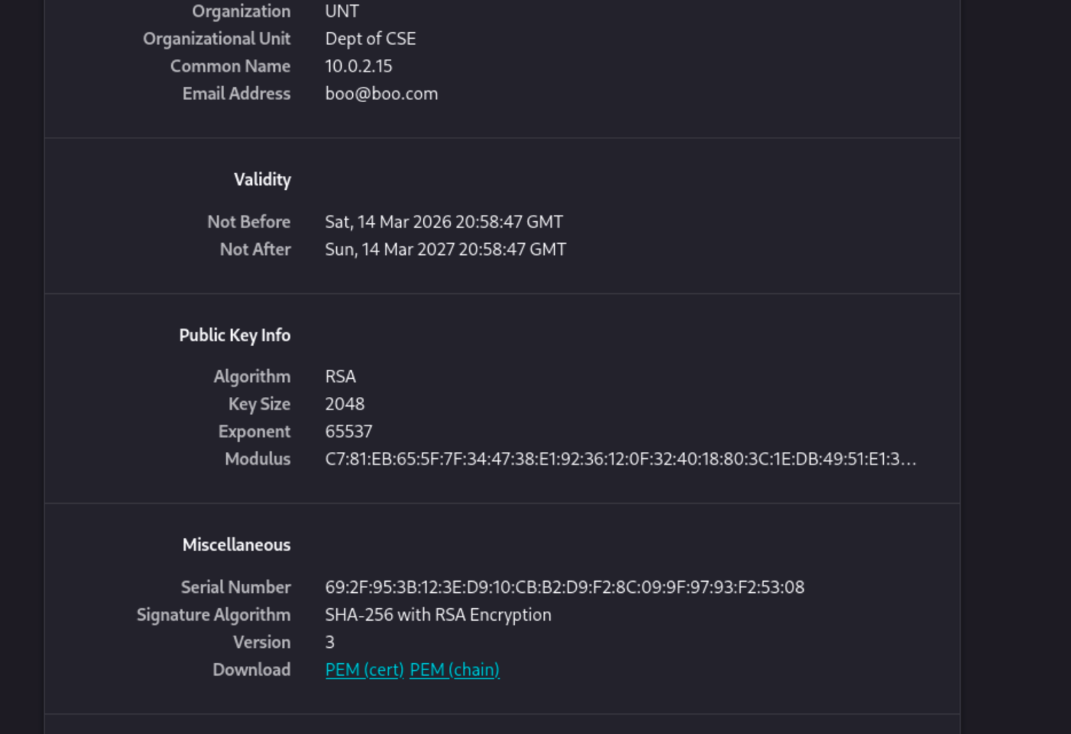
Figure 21Viewing the details of the self-signed SSL certificate showing the subject and issuer information
Fig 8. Here is an example of what we have achieved: after accessing the website to show us the warning and potential security risk.
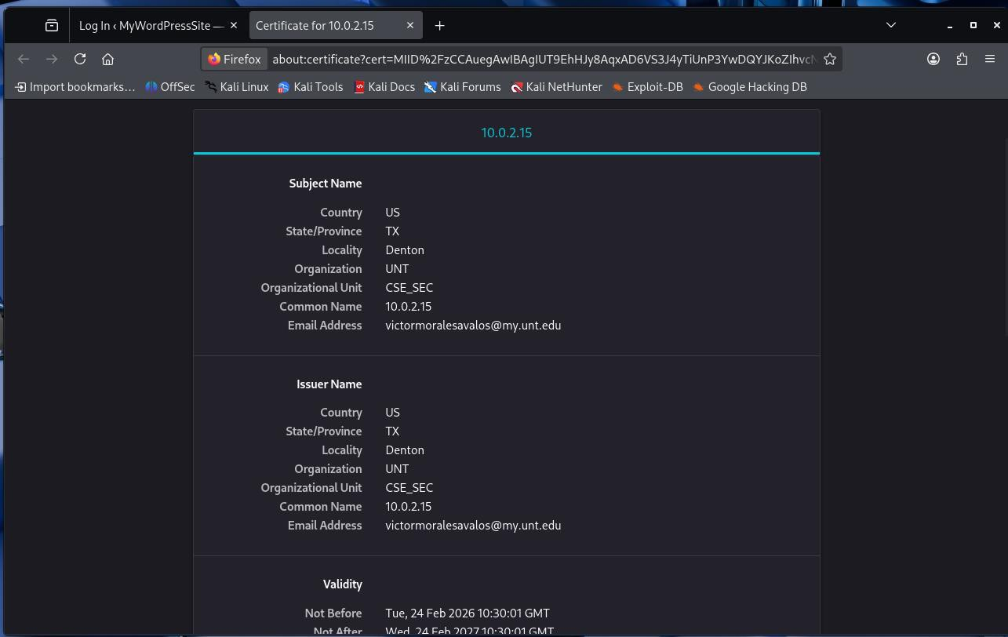
Fig 9. Here is an example of what we have achieved: after accessing the website.

During this phase of the lab, HTTPS encryption was set up so as to encrypt communication between the client browser and the Apache web server. In Apache, the default-ssl virtual host was configured and the SS module was turned on to enable the support of the ssl. A certificate management tool was used to generate a self-signed certificate, and set it up in the Apache file of the master of the Secure Socket Layer. In accessing the site via HTTPS, the browser sounded a warning security alert at the beginning since the certificate was not signed by a trusted certificate authority and it was self signed. Following the certificate acceptance, the web site was opened via an encrypted TLS connection which proved that secure communication was established correctly.

Refer to Table 1 again to structure your report submission. Be sure to explain each step of this lab in detail, focusing on setting up a full-stack web development environment on Kali Linux.

